WEEK 3
Sid: 2524517

Lab Logbook Requirement:
1) Draw a bicolour features interaction diagram between the columns with the numbers of the last and second-to-last digits of your SID, where:
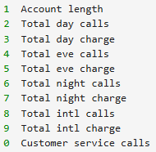
If these numbers are the same, use the following number in order as the other column number.
For example, if your SID is 2287477, then you should plot the bicolour diagram of the 7th and 8th columns. If your SID is 2287499, then the 9th and 0.
- Add the code and result to your Lab Logbook.

fig = plt.figure(figsize=(11, 7))

plt.scatter(
data['Account length'],
data['Total night charge'],
color=Clr,
s=(data['Total night charge'] + 0.05)
)

plt.xlabel('Account length')
plt.ylabel('Total night charge')
plt.title('Bicolour Features Interaction Diagram')
plt.show()

